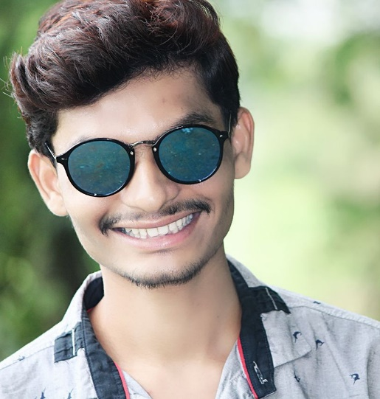 |  | Prafull Bansode  Actor/Dancer/Choreographer
Profile  Name : Prafull Bansode  Age : 22  Address : Hadapsar, Pune  Height : 5.5  Wight : 50  Skin tone : Fair  Eye color : black  Hair color : little brown/black mix  References : Available on request.  Contact  Mobile:  8378873597  EMAIL:  Prafullbansode14@gmail.com  Workshops and Training  Srujan Kalamanch and theater – Hadapsar pune  Dance Workshop by Mrunmayee sufal, Punyakar - PCMC  Swaranjali Bharatnatyam dance school – Hadapsar pune |  | Personal summery  A motivated, committed and talented actror with strong stage instincts and extensive formal training. I am committed to achieving the highest standard of performance and is always willing to listen and learn from others. I am energetic, prepared to 'go the extra mile' and is sure to make a real difference to any project I will involve in.  WORK EXPERIENCE  Paari Shortfilm  Worked as a Second lead Actor  Shram Marathi shortfilm  Worked as Actor  this film has so many awards.  Marathi Album songs and Bollywood movie songs  Worked as background Dancer  National Level Dance Competition  (National Harmony)  got second prize in this competition.  Proffesional Classical dancer  Done 5 exames of bharatnatyam.  SKILLS  Acting  Dancing  Singing  Makeup  Awards and Accolades :  Sinhagad Kalaratna Puraskar by actress Prajakta hanamghar in 2017

